**CREDIT READER ACCOUNTING**

**BASIC USER MANUAL**

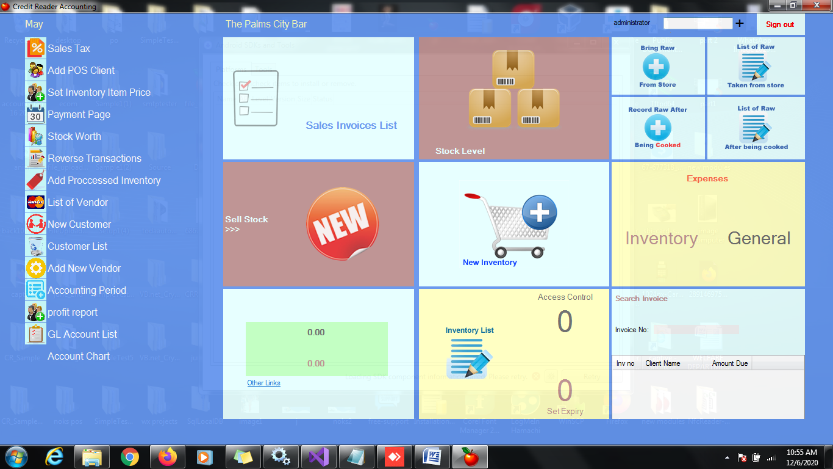



[**https://www.youtube.com/playlist?list=PLh1x2V7r1h4MjKZutYFluXJqKaeke4dMX**](https://www.youtube.com/playlist?list=PLh1x2V7r1h4MjKZutYFluXJqKaeke4dMX)

**Credit Reader User Guide**

|  |  |  |  |
| --- | --- | --- | --- |
| **SN** | **Description** | **Module** | **Remarks** |
| 1 | how to create a new company | settings and implementation |  |
| 2 | post inventory | inventory |  |
| 3 | how to use save record on inventory | inventory |  |
| 4 | how to update barcode | inventory |  |
| 4 | how to check inventory list | reports |  |
| 5 | post sales | sales |  |
| 6 | how to create income / servicing items | income and services |  |
| 7 | how add fast moving item to the buttons on the sales page | sales |  |
| 8 | how to save record for later usage | sales |  |
| 9 | selling without using category | sales |  |
| 10 | how to use barcode on sales page | sales |  |
| 11 | how create new customer on sales page | sales |  |
| 12 | the use short cut on sales page | sales |  |
| 13 | how to customize staff on the sales page button | sales |  |
| 14 | how to increase quantity on sales page | sales |  |
| 15 | everything about the sales report and how to end sale report | reports |  |
| 16 | how to send sales report before the end of sales | reports |  |
| 17 | how to check profit report | Business owner / Administrator |  |
| 17 | how to customize number of printed records | settings and implementation |  |
| 18 | how to delete existing company | Business owner / Administrator |  |
| 19 | Creating new employee | Business owner / Administrator |  |
| 20 | Access control and user right | Business owner / Administrator |  |
| 21 | Sending automatic total daily sales report Alert | Reports |  |
| 22 | Sending automatic sales alert on every invoices or sales | Settings and implementation |  |
| 23 | Checking Stock worth | Business owner / Administrator |  |
| 24 | Adding Processed Inventory Items | Inventory |  |
| 25 | Checking your printer default settings | Settings and implementation |  |
| 26 | How to reverse Transactions | Business owner / Administrator |  |
| 27 | Accounts Payable or debtors | Sales |  |
| 28 | How to sell using keyboard shortcut | Sales |  |